John Ellefson

**Site Plan**

**Site Purpose:**

Our purpose is to inform tourists visiting Cozumel of the best scooter rentals on the island, Scoots. Tourists need a cheap and flexible means of transportation which Scoots can supply at each of our two locations on the island. Users can learn of the various rentals available and even set up reservations through our website. We also provide possible sites to visit as well as some interesting facts about the island.

**Target Audience:**

Our target audience are those interested in visiting Cozumel Island: individuals, couples, families, corporate outings, etc.

ADDED: Tourists are not our only audience however, we also cater to locals who need a temporary, cheap and easy means of travel around the island.

Persona 1:

**Name:** Julian Miller  
  
**Occupation:** Construction Architect  
  
**Age:**  28  
  
**Marital Status:** Engaged  
  
**Overview:** Has a degree in architecture and is engaged. He and his fiancée are planning a trip to the Caribbean for their honeymoon. They are both interested in tropical fish, the outdoors, and would like to learn how to snorkel.

Persona 2:

**Name:** Alice Banks  
  
**Occupation:** Retired Nurse  
  
**Age:**  74  
  
**Marital Status:** Married, has three adult children  
  
**Overview:** Alice and her husband are taking a trip to the Caribbean to celebrate their 50th anniversary with their three children and their spouses. They are planning on visiting Cozumel Island during their visit and would like a group tour of the island.

**Site Map:**

**Color Scheme:**

**Typography:**

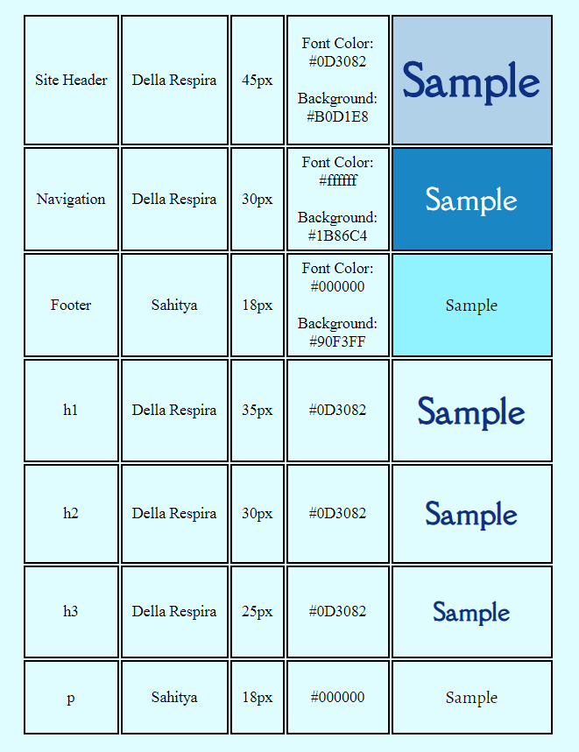

**Wireframes:**

**Large:**

**Medium:**

**Small:**